Introduction

* Sign language is a way of communicating using hand gestures and movements, body language and facial expressions, instead of spoken words.
* There are different sign languages
  + Indian sign language
  + American sign language
  + British sign language
* The sign language we are Recognising is INDIAN Sign Language

Problem Statement

To Identify the signs and gestures in Indian sign language and Translate into English

Existing System

* There are a few sign language translation systems
  + Sensor Gloves
    - Accurate
    - Easy to use
    - Costly
  + Algorithms to recognise signs
    - Cost effective
    - Uses color gloves sometimes to increase   
      Accuracy
    - Less accuracy for multi handed signs

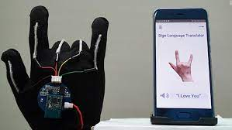 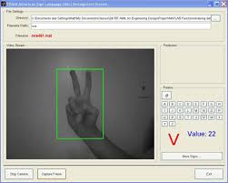

References

Research Papers

* [Sign Language Recognition Application Systems for Deaf-Mute People: A Review Based on Input-Process-Output](https://www.sciencedirect.com/science/article/pii/S1877050917320720)
* [Real time conversion of sign language to speech and prediction of gestures using Artificial Neural Network](https://www.sciencedirect.com/science/article/pii/S1877050918321331)
* [Preview attachment Sign language detection paper Ghaziabad.pdfSign language detection paper Ghaziabad.pdf663 KB.url](https://drive.google.com/file/d/1shxPAgjxEXbfGDJJPJCvVoPRw_ulz-9E/view?usp=sharing)

Official Sign translation and dictionary

* [ISL (Indian Sign Language Portal) || FDMSE || RKMVERI || COIMBATORE CAMPUS – Dictionary on Indian Sign Language (ISL) signs by FDMSE, Coimbatore](https://indiansignlanguage.org/)
* [Indian Sign Language Research and Training Center ( ISLRTC), Government of India](http://www.islrtc.nic.in/)

New papers

* <https://ieeexplore.ieee.org/document/8493808/references#references>
* [Indian sign language recognition using SVM](https://link.springer.com/article/10.1134/S1054661816020164)

Proposed system

* We propose to use Machine learning algorithms to recognise the   
  Gestures and signs in Indian sign language.
* We train the Machine learning model with videos containing signs and gestures in indian sign language.
* We will send the words identified to a sentence generator algorithm to make a proper english sentence with the generated words.
* Finally the generated output will be shown on screen and played out-loud using the device speaker.

Architecture

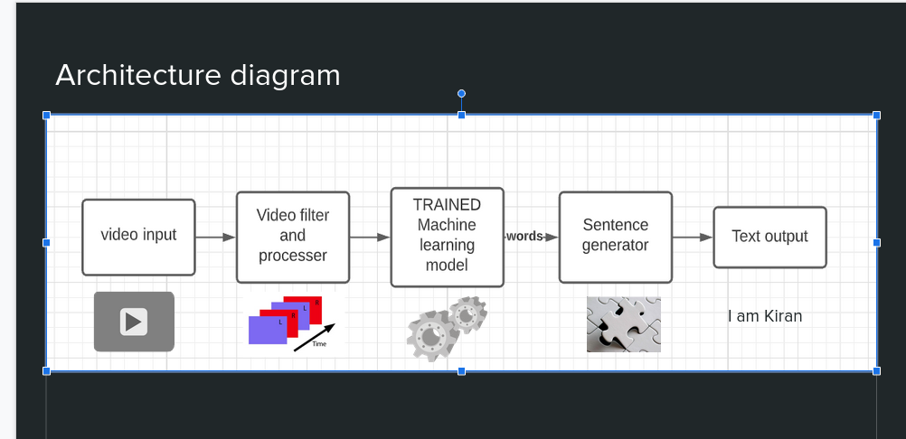

Words selected

1. hello
2. India / Indian
3. Sign
4. Language
5. Bye-bye
6. Again
7. i/me
8. You
9. Man
10. Woman
11. He
12. She
13. Deaf
14. Hearing
15. Teacher
16. Thank you
17. Thank you very much
18. Please
19. Time
20. Sorry
21. Namasthe
22. How are you
23. Im fine
24. Name
25. No
26. Good
27. Bad
28. Correct
29. wrong
30. Easy
31. Difficult
32. Child
33. Boy
34. Girl
35. Food
36. Good morning
37. Good afternoon
38. Peace
39. fear
40. Understand
41. place
42. Face
43. This
44. What
45. Why
46. How
47. Where
48. Who
49. When
50. Which
51. Colours
52. Family
53. Marry
54. Married
55. Mother
56. Father
57. Wife
58. Husband
59. Day
60. Week
61. Monday
62. Tuesday
63. January
64. February
65. Tree
66. Flower
67. House
68. Car
69. Apartment
70. Happy
71. Beautiful
72. Fat
73. Foolish
74. Greedy
75. Clever
76. Dark
77. Bright
78. Work
79. Hindi
80. Help
81. Water
82. Address
83. Cool
84. Hot
85. Sunny
86. Rain
87. Lunch
88. Hungry
89. Sad
90. Class
91. Mask
92. Careful
93. Phone
94. Sleep
95. Money
96. Mathematics
97. Mistake
98. Right
99. Left
100. Examination
101. Love
102. hate

Filtered words

1. Hello
2. Bye
3. How are you
4. I am fine
5. My name is Kiran
6. Namaste
7. Where are you from
8. Thankyou
9. Where is your home
10. Good morning
11. Good Night
12. Ok
13. No

Stage 2 words

Hello

Indian/india

Bye-bye

Thankyou

welcome

yes

No

i/me

You

Man

Woman

Datasets

[Indian Sign Language Dataset](https://www.kaggle.com/vaishnaviasonawane/indian-sign-language-dataset)

**STAGE -1**

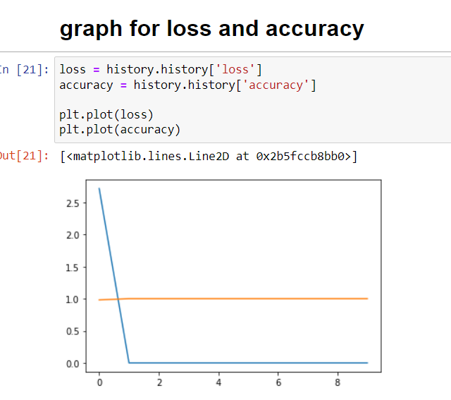

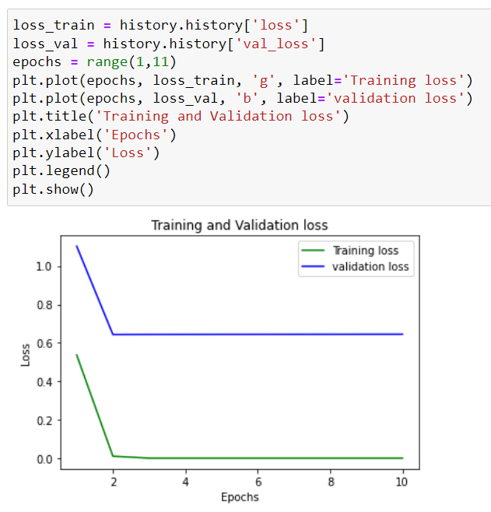

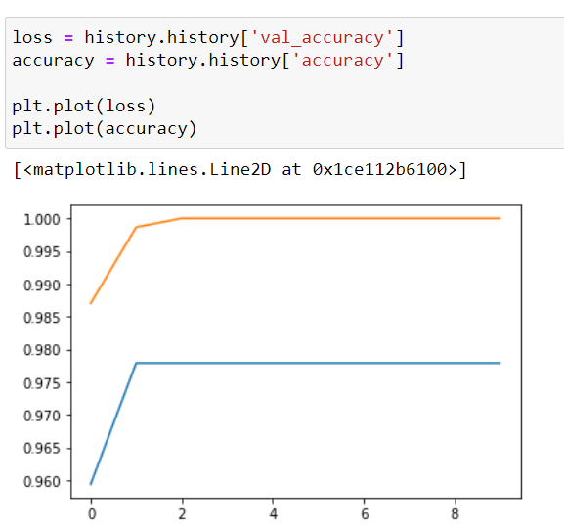

Saved models

1. stage 1 – less images
2. Stage 1_02 – more images
3. Stage 1_03 – using pickle and trained

Stage 1 - final

Cnn model with dense - original data

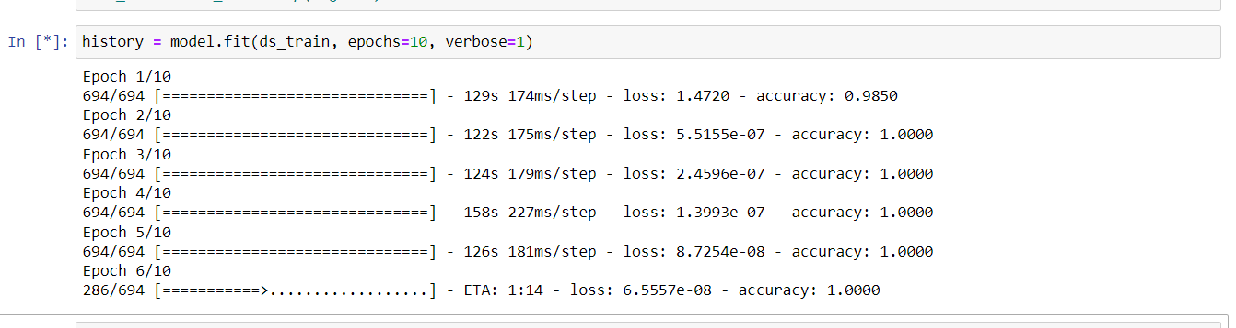

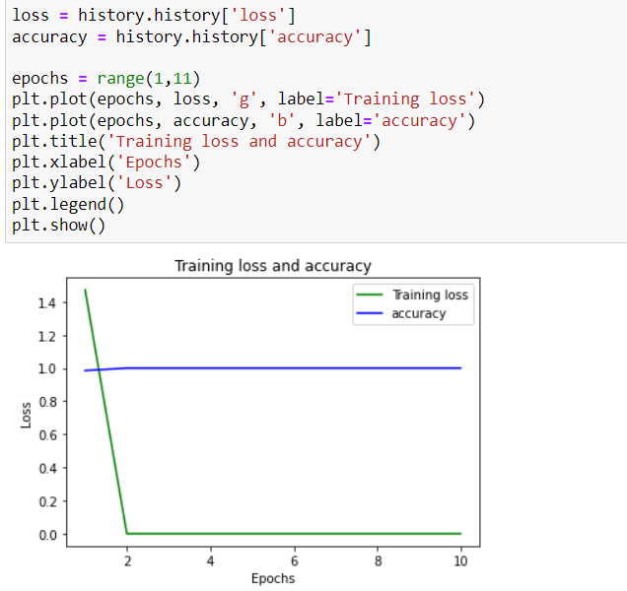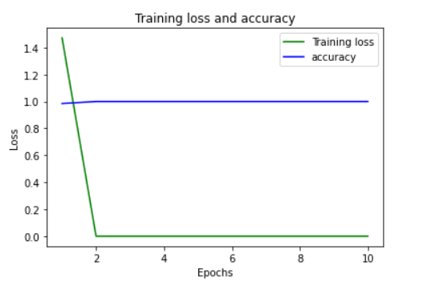

SVM

